# 30D – Experiment: Circuit Transients

**Theoretical Background**

The three circuits above were selected because they exemplify the behavior of capacitors, inductors, and resistors in circuits.

* If the capacitor in 1.a) is fully charged at *t* = 0, when the switch is opened, it will discharge through the resistor. Kirchhoff’s loop rule around the RC loop gives: $V_{C}-IR=\frac{Q_{C}}{C}+R\frac{dQ_{C}}{dt}=0$, and solving for charge as a function of time, $Q_{C}\left(t\right)=Q_{C}\left(0\right)e^{-t/RC}$, therefore $V_{C}\left(t\right)=V_{C}\left(0\right)e^{-t/RC}$ for *t* > 0.
* The current flowing through the inductor in 1.b) at t=0 is *I*0 and the potential across the inductor is zero. When the switch is opened Kirchhoff’s loop rule around the LR loop gives $V_{L}-IR=-L\frac{dI}{dt}-IR=0$, and solving for current as a function of time yields, $I\left(t\right)=I\left(0\right)e^{-Rt/L}$, therefore $V_{L}\left(t\right)=V_{L}\left(0\right)e^{-Rt/L}$ for *t*>0.
* For circuit 1.c) the current through the inductor is constant (*I*L(0)) and the voltage across the capacitor is zero for *t*<0. The loop law for t>0 is $V_{C}+V_{L}=-L\frac{di}{dt}-\frac{Q}{C}=-L\frac{d^{2}Q}{dt^{2}}-\frac{Q}{C}=0$, which yields solutions of the form $Q\left(t\right)=Asin(ωt+φ)$ with $ω=1/{\sqrt{LC}}$ and A and φ are constants determined by the initial conditions.

**Experimental Observations**

**Equipment**: M1K board with ALICE software; 1 capacitor (2.2 μF preferred); 1 inductor (4.7 mH preferred); 1 resistor (470 ohm preferred); electronic breadboard; 3 jumper wires.

* Record the nominal values of your components here.

Capacitor = ______________μF

Resistor = ______________ohms

Inductor = ____________mH

**RC Circuit**

The goal is for you to observe both the charging and discharging behavior of a capacitor in series with a resistor.

A square wave is used to drive a resistor and capacitor that are wired in series as shown here.

Open the ALICE M1K Desktop and plug in the M1K.

* Set up your breadboard with your resistor 1 and the capacitor in series. An example is shown in the image below.

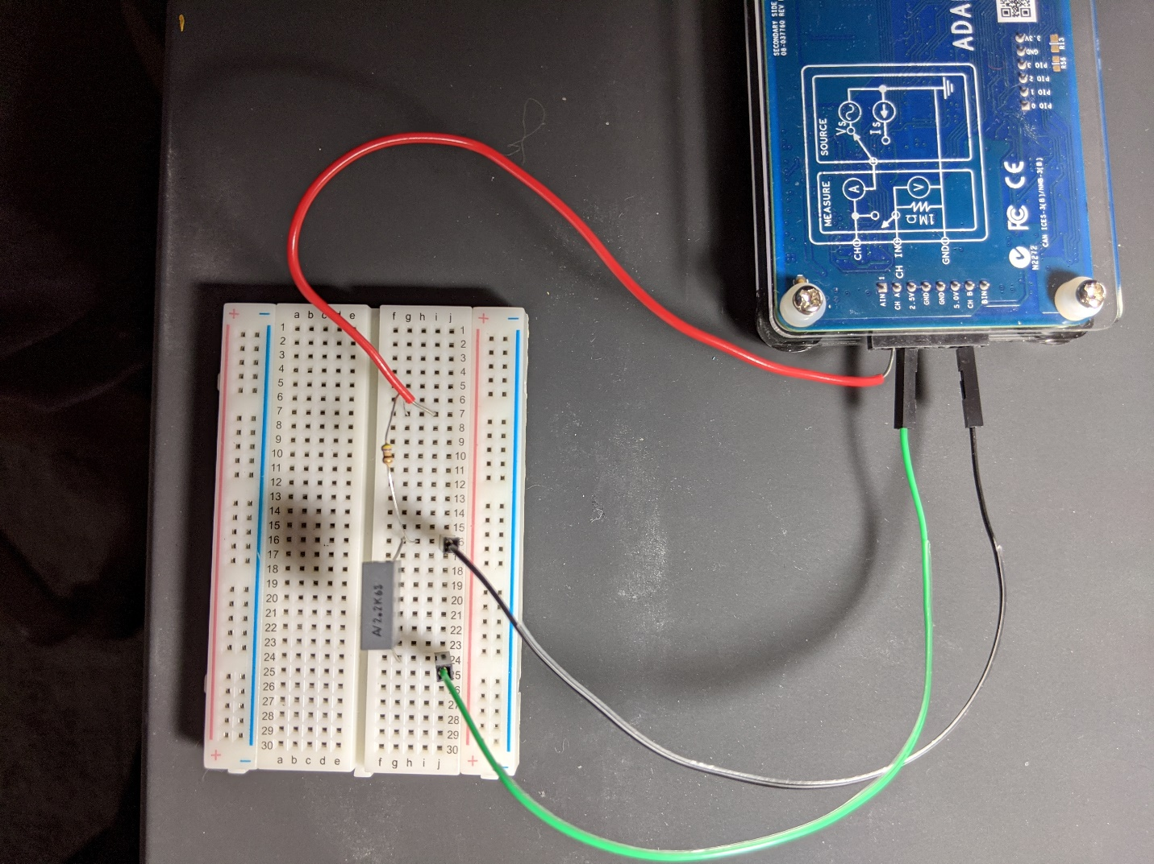

* Wire Ch A to one side of the resistor (red wire here) and the 2.5 V output to the other end of the circuit (green wire).
* Set up the ALICE oscilloscope using Ch A as the potential source.
  + Use the AWG Configuration Panel to set up the measurement channels.
    - AWG CH A
      * Mode = SVMI with Term = To 2.5
      * Shape=Square; Freq Ch A=50 Hz
      * Min Ch A = 1.0; Max Ch A = 4.0
    - AWG CH B to Hi-Z with Term=Open (This disconnects B from its source voltage. Other settings are unimportant.) Also, uncheck the Sync AWG box.
  + Here are suggested settings for getting started. You should vary them to optimize your view.
    - On the menus bar across the top of the oscilloscope frame
      * Curves menu, choose CA-V and CB-V
      * Trigger menu select CA V and Auto level.
      * Edge menu = Rising
      * Time mS/Div = 2.0 mS/Div
    - On the settings bar across the bottom of the oscilloscope select CA V/Div, CA V Pos, CB V V/Div, and CB V Pos to get both Channel A and Channel B Voltage on the screen with each signal filling most of the vertical range. (You will find it best to set the CA and CB V Position to 2.5 V.) An example screen is shown below.

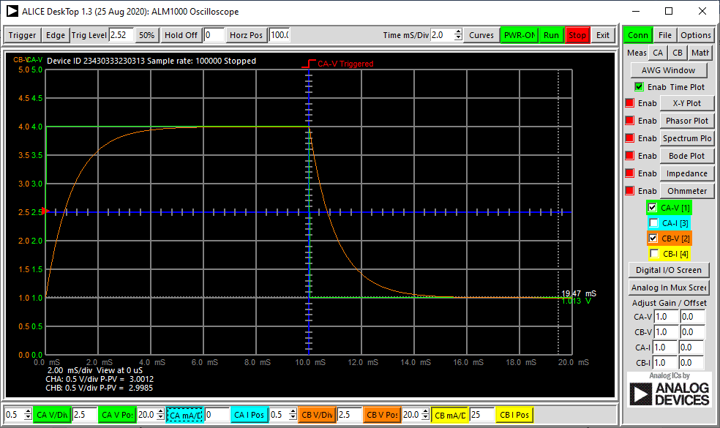

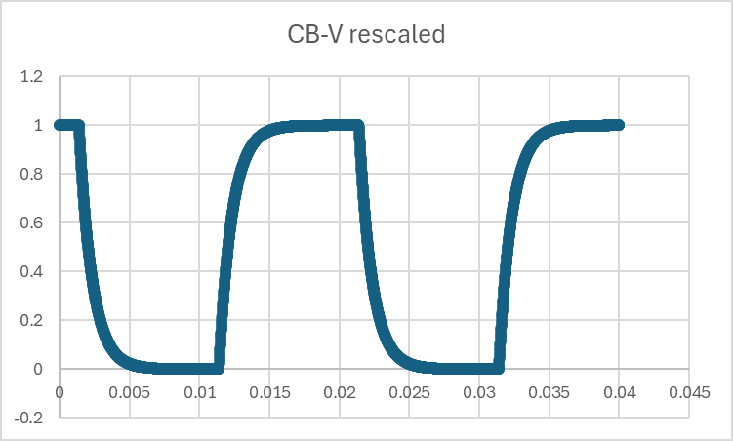

* Stop the scan and use the File menu to “Save to CSV” the data
* Select the range of data from the saved spreadsheet so you can plot one cycle (~0.02 s) of the CB V data with a rising edge and a falling edge. Rescale CB V by subtracting 1 V (the minimum value in the raw data) and dividing by 3 V (the peak-to-peak voltage). Insert your plot of the scaled CB V scan vs time here.

We expect the scaled voltage $V_{scaled}$ during the decay portion of the scan to have the form: $V_{scaled}(t)=e^{-\frac{(t-t_{0})}{τ}}$ 
 , where $τ$ is the decay time constant and (*t-t*0) is the time after the decay starts.

* What would be the scaled CB V value be when the scaled voltage has decayed by one time constant?

$V_{scaled}(\left(t-t_{0})=τ\right)=$

_____________

* Measure the time constant experimentally by finding the value of $(t-t_{0})$ at which $V_{scaled}$ is equal to the value you gave above. (You might find it easiest to use your Excel spreadsheet to do this.)

$τ_{experimental}$ =______________s +/-_____________s

* Calculate the decay time constant, τ, using the nominal values of the capacitance and resistance for your components.

$τ_{calculated}$ =_______________s

Compare your measured time constant to your calculated time constant. Are they consistent with your estimated uncertainty in the measurement?

**The LC Circuit**

The goal of this segment is for you to observe the transient oscillation of voltage on the capacitor in an LC circuit. The concept of this circuit is shown in the schematic here.

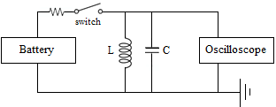

In our experiment, we substitute a diode for the switch. (The diode allows current to flow when the output voltage is positive and isolates the inductor and capacitor from the source when the voltage is negative.)

Channel A will serve as a potential source that switches from positive to negative, charging the circuit during the positive part of the cycle and isolating during the negative. We are interested in the portion of the cycle when the inductor and capacitor are isolated from the source.

* Wire the diode, resistor, inductor, and capacitor as shown in the schematic. An example image is shown here.

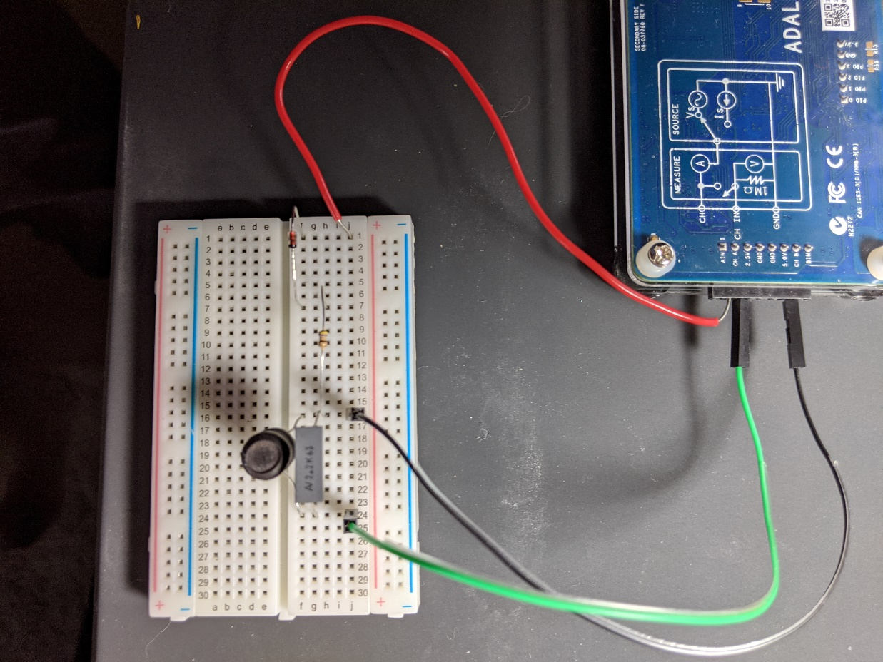

diode

resistor

inductor

capacitor

* Set up the ALICE oscilloscope using Ch A as the potential source.
  + Use the AWG Configuration Panel to set up the measurement channels.
    - AWG CH A
      * Mode = SVMI with Term = To 2.5
      * Shape=Square; Freq Ch A=50 Hz
      * Min Ch A = 1.0; Max Ch A = 4.0
    - AWG CH B to Hi-Z with Term=Open (This disconnects B from its source voltage. Other settings are unimportant.) Also, uncheck the Sync AWG box.
  + Here are suggested settings for getting started. You should vary them in order to optimize your view.
    - On the menus bar across the top of the oscilloscope frame
      * Curves menu, choose CA-V and CB-V
      * Trigger menu select CA V and Auto level.
      * Edge menu = Falling
      * Time mS/Div = 2.0 mS/Div
    - On the settings bar across the bottom of the oscilloscope select CA V/Div, CA V Pos, CB V V/Div, and CB V Pos to get both Channel A and Channel B Voltage on the screen with each signal filling most of the vertical range. (You will find it best to set the CA and CB V Position to 2.5 V.) An example screen is shown below.
* Adjust your CB V/div and Time mS/div settings in order to get a clear image of several LC oscillations on screen. *(See a scaled example below, at the very end of this file.)
* Stop the scan and use the File menu to “Save to CSV” the data
* Import the data into Excel (or similar program) and select a time range that provides a plot of your CB V data showing the oscillations clearly.
* Insert your plot of the LC oscillation data here.

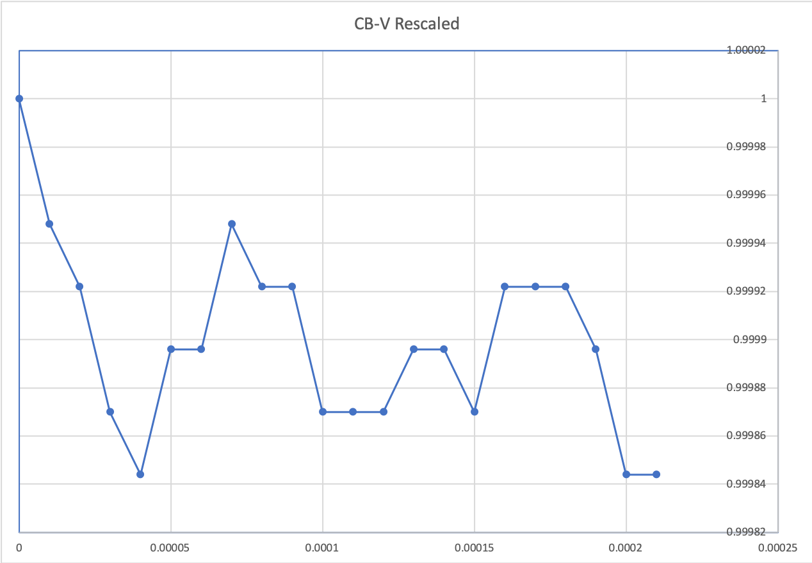

* Estimate the frequency, *f*, of your experimental oscillation signal by measuring the period of the oscillations.

Observed period = ___________________s

$f_{experimental}$*=*___________________Hz

* What is the theoretical form for oscillation frequency in Hz in terms of the inductance and capacitance?

*f* =____________________

* Calculate the expected frequency of oscillation in Hz using the nominal values of capacitance and inductance for your components.

$f_{calculated}=$______________Hz

* Is the frequency value you calculated in consistent with the value you measured? (If it is off by a lot, check that you have properly converted from angular frequency in radians per second to frequency in cycles per second.)

The theory discussed in lecture implies that LC oscillations continue forever after they start. We expect that you observed that the oscillation amplitude decays rapidly. Why do think this decay occurs?

* Scaled example of LC oscillations.